zoho interview question and answer in programming round

[](http://3.bp.blogspot.com/-nFMH8i24sqI/VaVMBsJuoYI/AAAAAAAAARc/qM8lvkJSX_Q/s1600/zoho.jpg)

**Display Pattern**

**Problem Statement**

Print the word with odd letters as

**Input Format**

String should have odd number of characters.

**Output Format**

**[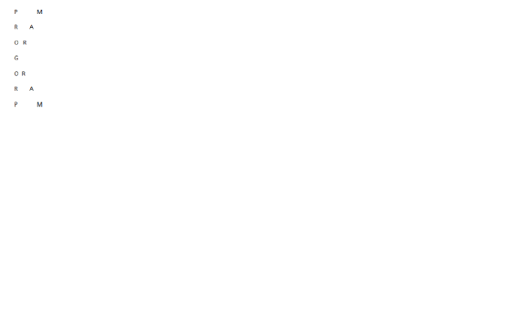](http://4.bp.blogspot.com/-KIGOaQpEHgA/VaVITiLHQOI/AAAAAAAAARQ/epv8MSSlE2o/s1600/as.png)**

Refer above pattern

**Sample Input**

PROGRAM

**Sample Output**

Refer above pattern

**Code:**

#include <stdio.h>

#include <string.h>

#include <math.h>

#include <stdlib.h>

int main() {

    char a[100];

    int i,j,b,k,n;

    scanf("%s",a);

    n=strlen(a);

    for(i=0,j=n-1;i!=j;i++,j--)

        {

        printf("%c",a[i]);

        for(k=1;k<n/2;k++)

            {

            printf(" ");

        }

        printf("%c",a[j]);

        n=n-2;

        printf("\n");

    }

    n+=2;

   printf("%c\n",a[i]);

     for(i--,j++;i>=0;i--,j++)

        {

        printf("%c",a[i]);

        for(k=1;k<n/2;k++)

            {

            printf(" ");

        }

        printf("%c",a[j]);

        n=n+2;

        printf("\n");

    }

    return 0;

}

CPP:

#include<iostream.h>

#include<conio.h>

#include<string.h>

int main()

{

int i,j,n;

char a[100];

clrscr();

cout<<"enter the string:";

cin>>a;

n=strlen(a);

for(i=0;i<n;i++)

{

//for(j=n;j>=0;j--)

for(j=0;j<=n;j++)

{

if((j==0 )||(i-j==(n/2)))

{

cout<<a[i];

}

if((i+j==(n-4)) && (i!=(n/2)))

{

cout<<a[j+(n/2)];

}

cout<<"\t";

}

cout<<"\n";

}

getch();

return 200;

}

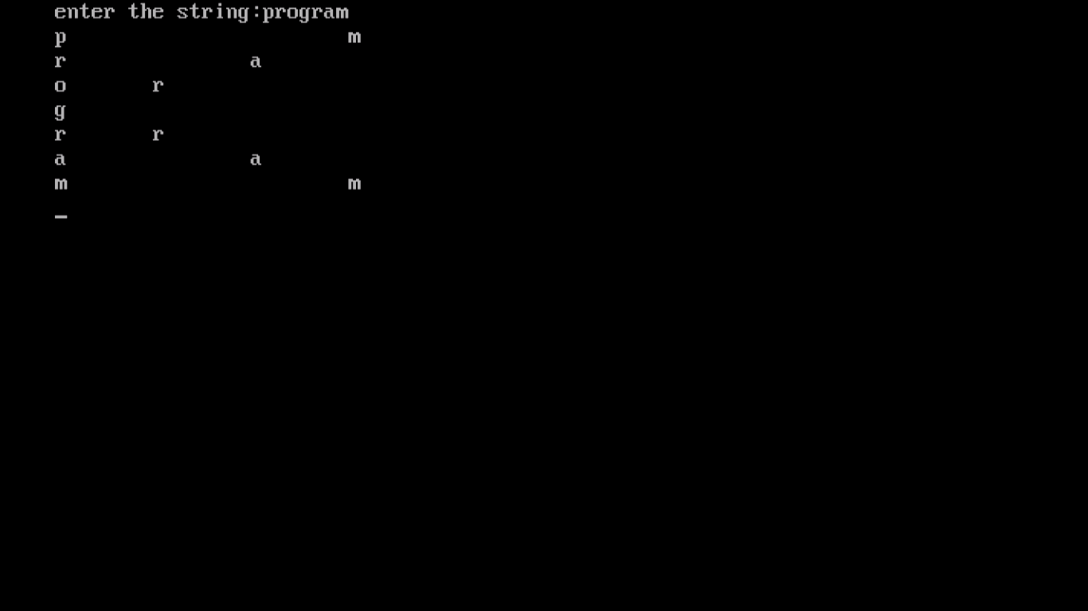

**Twice the Vowel**

**Problem Statement**

If a vowel is found in the given string twice that vowel character of a string in the same array efficiently.

**Input Format**

The first line contains the number of test cases T. Next T lines contains an input string.

**Output Format**

Print the modified string.

**Sample Input**

1

Tamil

**Sample Output**

Taamiil

**Code:**

#include<stdio.h>

int check_vowel(char);

int main()

{

  char s[100];

  int i, j = 0;

    int count=0;

    int n;

    scanf("%s",s);

    n=strlen(s);

printf("%d%s",n,s);

 for(i = 0; i<n; i++)

  {

    if(check_vowel(s[i])==1)

    {

        for(j=n-1;j>=i;j--){

            s[j+1]=s[j];}

        i++;

    }

    n++;

      }

  printf("String after repeating vowels: %s\n", s);

  return 0;

}

int check_vowel(char c)

{

  switch(c) {

    case 'a':

    case 'A':

    case 'e':

    case 'E':

    case 'i':

    case 'I':

    case 'o':

    case 'O':

    case 'u':

    case 'U':

      return 1;

      break;

    default:

      return 0;

  }}

(OR)

#include<stdio.h>

#include<conio.h>

int main()

{

char a[100];

int i,t,n,j;

clrscr();

printf("enter the string:");

scanf("%s",a);

n=strlen(a);

for(i=0;i<n;i++)

{

switch(a[i])

{

case 'a':

case 'e':

case 'i':

case 'o':

case 'u':

case 'A':

case 'E':

case 'I':

case 'O':

case 'U':

printf("%c%c",a[i],a[i]);

i++;

default:

printf("%c",a[i]);

}

}

getch();

return 200;

}

**String Rotation 1**

**Problem Statement**  
Given two string s1 and s2 how will you check if s1 is a rotated version of s2 ?  
If s1 = “crazyforcode” then the following are some of its rotated versions:  
“forcodecrazy”  
“codecrazyfor”  
 **Input Format**  
Two strings S1 and S2.  
Length(S1), Length(S2) > 1  
 **Output Format**  
Print "YES" or "NO" without double quotes.  
 **Sample Input**  
crazyforcode  
codeforcrazy  
 **Sample Output**  
NO

**code:**

#include <stdio.h>

#include <string.h>

#include <math.h>

#include <stdlib.h>

int main() {

    char a[100],b[100],t[100];

    int i,j,n,count;

    scanf("%s%s",a,b);

    n=strlen(a);

        for(j=0,i=0;j<n;j++){

            if(b[i]==a[j])

                {

                count++;

                i++;

            }

            else{

                i=0;

                count=0;}

        }

    for(i=0,j=0;i<n;i++,count--)

        {

        if(count>0)

            t[i]=a[n-count];

        else{

            t[i]=a[j++];

        }

    }

    count=0;

    for(i=0;i<n;i++){

        if(b[i]==t[i])

            count++;

    }

    if(n==count)

        printf("YES");

    else

        printf("NO");

    return 0;

}